2.3.1 Student centric methods, such as experiential learning, participative learning and problem-solving methodologies are used for enhancing learning experience and teachers use ICT- enabled tools including online resources for effective teaching and learning process.

ACE Engineering College (ACE) is one of the premier educational institutions, is committed to imparting quality technical education and training. We integrate various effective teaching and learning methodologies to provide our students with a comprehensive, dynamic, and professional educational experience. We leverage the power of technology to make education more interactive, engaging, and student-centric.

Experiential Learning Methodologies:

• Industrial Internships/Visits: ACE encourages students to undertake internships or industrial visits. This gives students hands-on experience and an understanding of the operational aspects of their respective industries.

• Learning by Doing: Labs and projects form the core part of our curriculum. Students engage in practical work, performing experiments, data analysis, and gaining practical insights into their subjects.

• Demonstration of Working Models/Experiments: ACE conducts project expos across all courses, enabling students to showcase their work. These expos enhance the learning experience by enabling students to see the application of theories and concepts they learn in class.

• Utilization of Online Resources: ACE uses video lectures and online courses from platforms like NPTEL, MOOCs, Coursera to provide diverse learning materials. This allows students to learn at their own pace and delve deeper into areas of interest.

Participative Learning Methodologies:

• Hackathons/Ideathons: At ACE, we believe in the power of practical learning and its integration into our curriculum. To this end, we consistently host hackathon and Ideathon, serving as platforms for our students to display their problem-solving and coding abilities. These events challenge students with real-world issues, providing an avenue for them to apply the theoretical knowledge gained from their coursework. This method of learning not only encourages their practical understanding but also nurtures their ability to collaborate effectively, preparing them well for their future careers.

• Promoting Academic Excellence: Journals, Conferences, and Innovations: At MGIT, we champion academic excellence by encouraging students to contribute to journals, present at conferences, and innovate with patent-worthy ideas. Our focus is on fostering research, nurturing creativity, and highlighting the importance of intellectual property in shaping future tech leaders.

• Interactive Communication Skills, Group Discussions, Technical Presentations, and Debates: At ACE, we enrich student learning by integrating interactive activities, group discussions, technical presentations, and debates into our curriculum. By focusing on trending tech topics and ethical aspects of technology, we aim to boost communication skills, foster critical thinking, and deepen subject understanding. These activities ensure our students are well-rounded, articulate, and prepared for professional scenarios.

• Membership in Professional Societies: ACE highly recommend Students to take Membership in professional societies such as ISTE, CSI, IETE and many others. They also recommend to actively participate in activities organized by these societies, as they offer a multitude of advantages. These societies provide opportunities to engage with like-minded peers, network with industry professionals, and stay abreast of the latest trends in the industry, thereby enriching the educational experience and professional growth.

• Technical Clubs/Fests: At ACE, we foster a culture of experimentation and creativity through various technical clubs and fests. These platforms allow students to engage with like-minded peers, share ideas, and work on innovative projects. For instance, a student can gain hands-on experience in designing, programming, and operating drones by participating in a Robotics Club. Similarly, our tech fests offer opportunities for students to showcase their projects, learn from their peers, and connect with industry professionals.

• Hands-on Training Programs/Workshops: To ensure our students are abreast with the latest industry trends, we collaborate with industry partners to conduct regular workshops and training programs. These sessions, ranging from coding bootcamps to technology specific workshops, offer students hands-on training, enhancing their practical knowledge and making them industry-ready.

• Guest Lectures/Seminars: Recognizing the significance of industry-academia interactions in shaping our students' future careers, ACE regularly hosts guest lectures and seminars. We invite industry professionals and renowned academicians to share their expertise and insights. These events offer students the opportunity to understand current industry trends, explore potential career opportunities, and learn about the practical applications of their course concepts. Through these engagements, we strive to equip our students with the right blend of academic and industry perspectives, preparing them for successful careers ahead.

• Online Learning: At ACE, we're embracing the digital revolution in education through the use of Massive Open Online Courses (MOOCs) and flipped classroom methodologies. We offer our students the flexibility to learn from world-renowned educators via MOOC platforms like Coursera and adopt a flipped classroom model for in-depth, interactive learning experiences. These approaches encourage active learning, foster deeper understanding, and accommodate individual learning paces.

Problem-Solving Methodologies:

• Industry oriented mini projects and Major Projects: Industrial oriented mini projects and major projects engage students in addressing real-world problems, enabling them to apply their theoretical knowledge to practical scenarios. This cultivates analytical and innovative thinking.

• Collaborative Learning through Structured Enquiry Tutorials and Group Assignments: As part of our curriculum at ACE, we support collaborative learning through structured enquiry tutorials and group assignments. These methodologies are designed to enhance problem-solving capabilities and encourage team spirit among our students.

• Engagement with Quizzes and Puzzles: To make learning more engaging and interactive at ACE, we incorporate quizzes and puzzles into our teaching practices. These tools not only provide a fun learning environment but also help sharpen our students' critical thinking skills.

• Real-World Learning through Case Studies: We believe in grounding academic learning in real-world contexts at ACE. Therefore, we employ case studies to deepen our students' understanding and application of the concepts learned.

At ACE, we are committed to encouraging a comprehensive learning environment that prepares students for successful careers in technology. Through a blend of hands-on, participative learning methodologies, we equip students with the necessary skills and knowledge, ready to face future challenges.

Use of ICT-Enabled Tools:

• Learning Management System (LMS): Faculty members use LMS platforms like ERP-BEES for disseminating course content, monitoring students' progress, and automating grading processes.

• ICT-Based Teaching and Learning: Various ICT tools are used, such as online classes using Webex, Google Meet, animation for presentations, multimedia for classroom presentations, and virtual labs are used to create a rich learning environment.

• Audio-Visual Center: ACE has an Audio-Visual Center that enhances students' learning experiences, especially in English language proficiency. The Center employs ICT tools to boost creative thinking, critical thinking, and decision-making skills among students.

Additional Resources:

• Faculty Blogs and Websites: Various faculty members maintain blogs and websites to share materials with students.

• Online Class Recordings: Recordings of online classes are available for students to review and revise at their convenience.
o These can be accessed at: https://www.youtube.com/@aceengcollege/streams

• High-Value Training Programs and Certifications: ACE offers internationally recognized training programs and certifications such as CISCO and TASK training. These programs equip our students with industry-relevant skills, enhancing their employability.

• Collaborations and Partnerships: We have many collaborations with leading IT and ITES companies, as well as strategic partnerships with defense services such as DRDO and DRDL. Through these partnerships, our students have unique opportunities to engage in hands-on learning. They can participate in industrial visits, internships, and both mini and major projects.

• 'Get Job Ready' - An AI-based Job Ready portal: Our unique AI-based portal prepares students for the industry, simulating real-world problems and evaluating their skills and assessments can be submitted to the companies.

• Campus Recruitment Training (CRT): Our dedicated placement cell conducts regular training sessions that help students prepare for job interviews and assessments, focusing on aptitude, technical skills, soft skills and personality development. ACE, with its student-centric methodologies, high-value training programs, collaborations, AI-based assessment, placement training, and internship opportunities, provides its students with the right blend of knowledge and skills for a successful technical career. The institute continues to enhance the learning experience through a blend of experiential, participative, and problem-solving methodologies, and the effective use of ICT-enabled tools.

DEPARTMENT OF COMPUTER SCIENCE AND ENGINEERING
NPTEL CERTIFICATES OF STUDENTS
A.Y 2024-25
S.NO | Name of the student | Name of the Course | Score
Jan-June 2024
1 | Navya Sai Sdu | The Joy of Computing Using Python | 73
2 | K Krithika Reddy | The Joy of Computing Using Python | 70
3 | B. Sree Sathya | The Joy of Computing Using Python | 69
4 | S. Hrithika Reddy | The Joy of Computing Using Python | 66
5 | Anju Nisha Reddy | The Joy of Computing Using Python | 64
6 | Ritish Sanala | The Joy of Computing Using Python | 61
7 | Nupur Gupta | The Joy of Computing Using Python | 61
8 | Pranitha | The Joy of Computing Using Python | 60
9 | Guna Yashwanth | The Joy of Computing Using Python | 60
10 | Siddharth Reddy | The Joy of Computing Using Python | 58
11 | S Giridhar Reddy | The Joy of Computing Using Python | 58
12. | V Pabbathi | The Joy of Computing Using Python | 58
13. | P. Manasa | Problem-Solving Through Programming In C | 55
14. | V. Akshaya | The Joy of Computing Using Python | 55
15. | K. Lavanya | The Joy of Computing Using Python | 55
16. | MD Sana | The Joy of Computing Using Python | 54
17. | Lubina Tabassum | The Joy of Computing Using Python | 54
18. | B. Jashwanth | The Joy of Computing Using Python | 53
19. | V. Bhavya Sri | The Joy of Computing Using Python | 53
20. | S. Haswin Chony | The Joy of Computing Using Python | 52
21. | Nithya Sri | The Joy of Computing Using Python | 51
22. | V Ashwitha | The Joy of Computing Using Python | 50
23. | Rohana | The Joy of Computing Using Python | 49
24 | V Saipriya | The Joy of Computing Using Python | 49
25 | P. Bhargava Sai | The Joy of Computing Using Python | 48
26 | P Akanksha | The Joy of Computing Using Python | 48
27 | L Sania | The Joy of Computing Using Python | 47
28 | G. Jeevana | The Joy of Computing Using Python | 45
29 | B N Pranavika | The Joy of Computing Using Python | 45
30 | B. Jashwanth | Problem-Solving Through Programming In C | 40
July-Dec 2024
1 | Senona Persis Madanu | Programming In Java | 55
2 | Bandi Sree Satya | Programming In Java | 58
3 | K Sai Karthika Reddy | Programming In Java | 65
4 | G Jeevana | Programming In Java | 63
5 | Srilakshmi | Programming In Java | 55
6 | S Sai Abigna | Programming In Java | 60
7 | M D Sana | Programming In Java | 51
8 | T Prasanna | Programming In Java | 53
9 | S Haswin Chony | Programming In Java | 52
10 | A Shaikh | Programming In Java | 56
11 | Akshya Sriram | Programming In Java | 57
12. | G Durga Prasad | Programming In Java | 58
13. | M Suda | Programming In Java | 50
14. | A Nisha Reddy | Programming In Java | 55
15. | S Sri Sai | Programming In Java | 68
16. | S Sri Sai | Programming in Mordern C++ | 55
17. | S Sri Sai | The Joy of Comuting Using Python | 71
18. | L Gangothri | The Joy of Comuting Using Python | 61
Total

Name of the Course | Duration (WEEKS) | Learning Platform | No of students Completed
NPTEL(The Joy of Computing Using Python ) | 12 | SWAYAM | 30
NPTEL( Problem-Solving Through Programming In C ) | 12 | SWAYAM | 2
NPTEL( Programming In Java ) | 12 | SWAYAM | 15
NPTEL( Programming in Mordern C++ ) | 12 | SWAYAM | 1

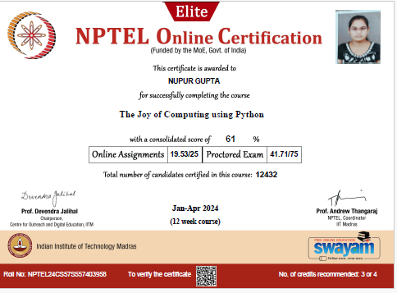

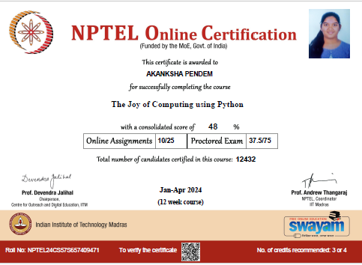
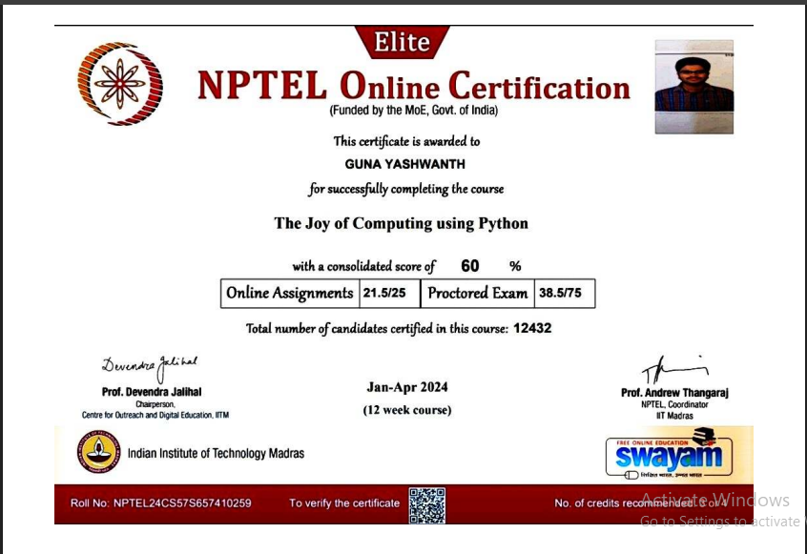
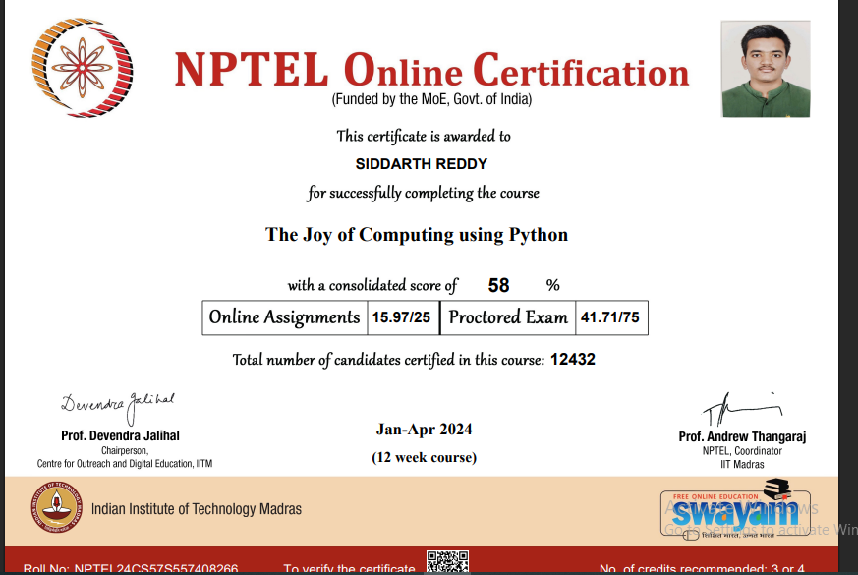
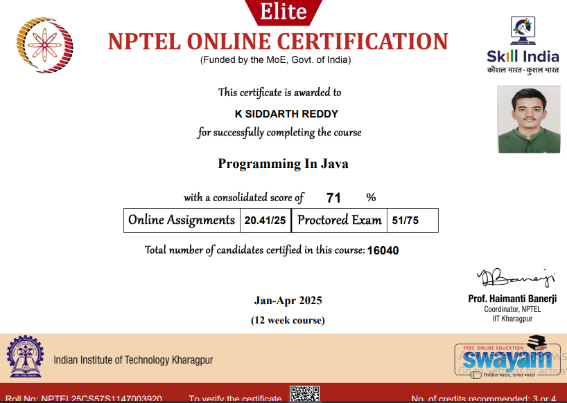

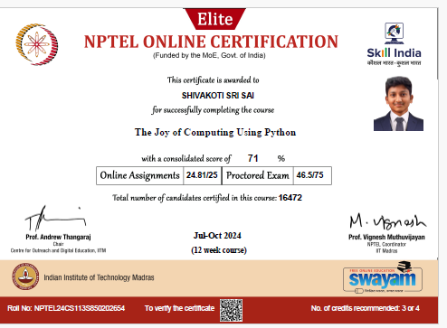
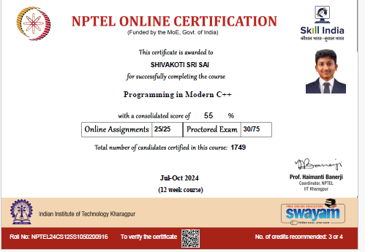

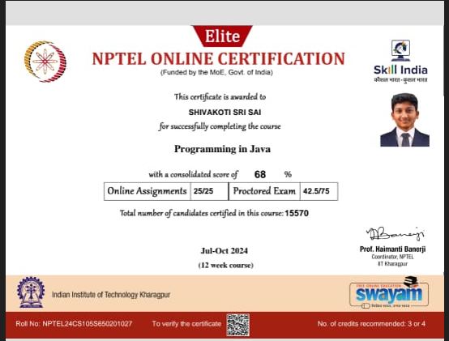
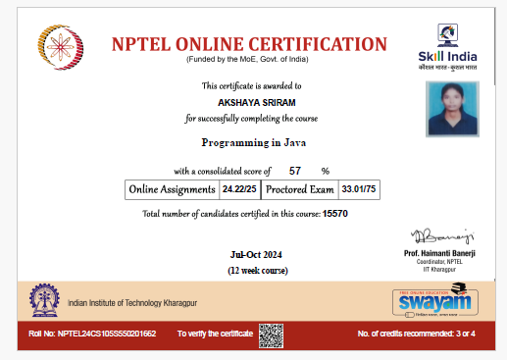

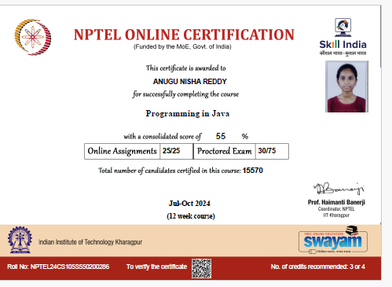

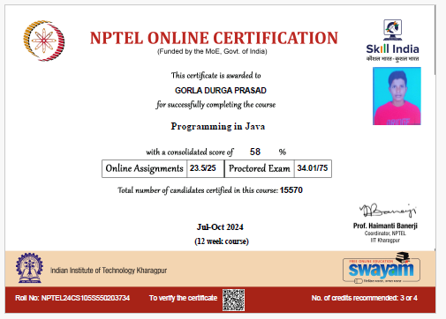
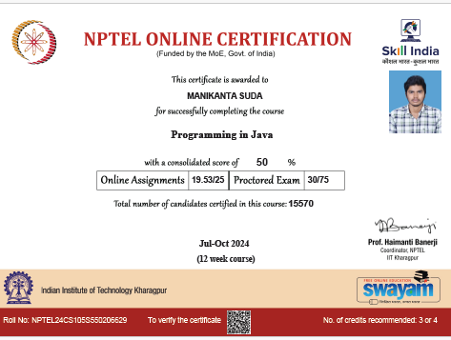

DEPARTMENT OF CSE (ARTIFICIAL INTELLIGENCE AND MACHINE LEARNING)
Student NPTEL Certifications (A.Y 2024-2025)
S.no | Name of the Course | Roll No | Year & Section | Name of the Student | Timeline | Duration
1. | Problem Solving through Programming in C | 24AG1A6641 | I-A | M. Sri Krishna Chaitanya | Jan- Apr 2025 | 12 weeks
2. | Problem Solving through Programming in C | 24AG1A6659 | I-A | S Lakshmi Chaturya | Jan- Apr 2025 | 12 weeks
3. | Problem Solving through Programming in C | 24AG1A6617 | I-A | D Harika | Jan-Apr 2025 | 12 weeks
4. | Problem Solving through Programming in C | 24AG1A6664 | I -A | Y. Sai Kiran | Jan-Apr 2025 | 12 weeks
5. | Problem Solving through Programming in C | 24AG1A6650 | I-A | P Supriya | Jan-Apr 2025 | 12 weeks
6. | Problem Solving through Programming in C | 24AG1A6607 | I-A | B.Pallavi | Jan-Apr 2025 | 12 weeks
7. | Problem Solving through Programming in C | 24AG1A66E3 | I-C | CH. Jayanth Sai | Jan-Apr 2025 | 12 weeks

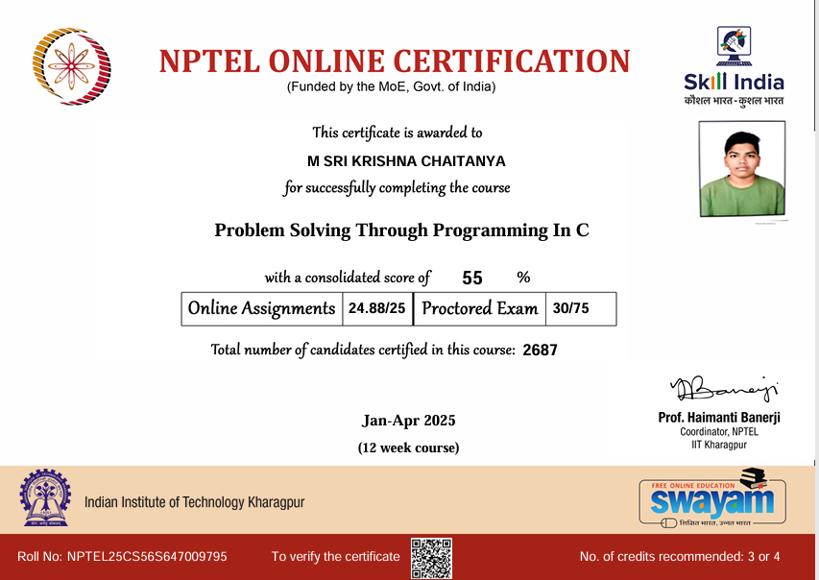
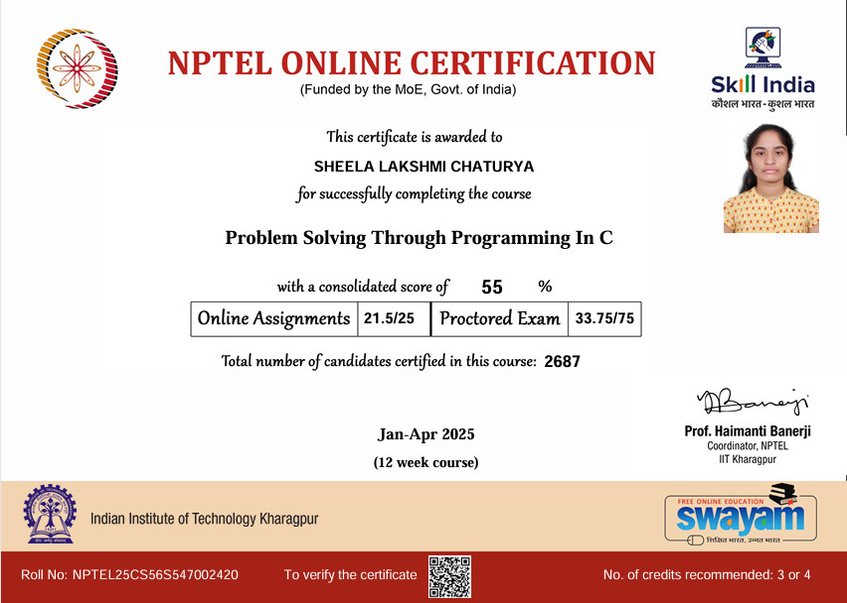
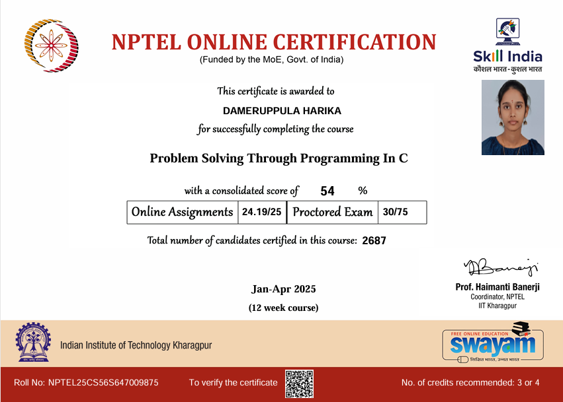

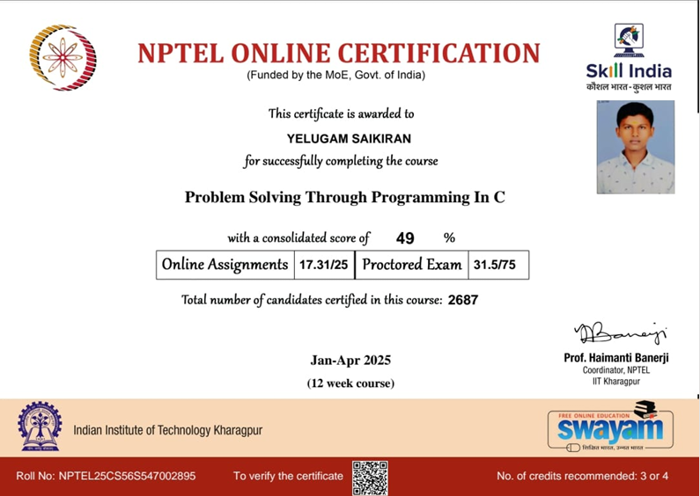

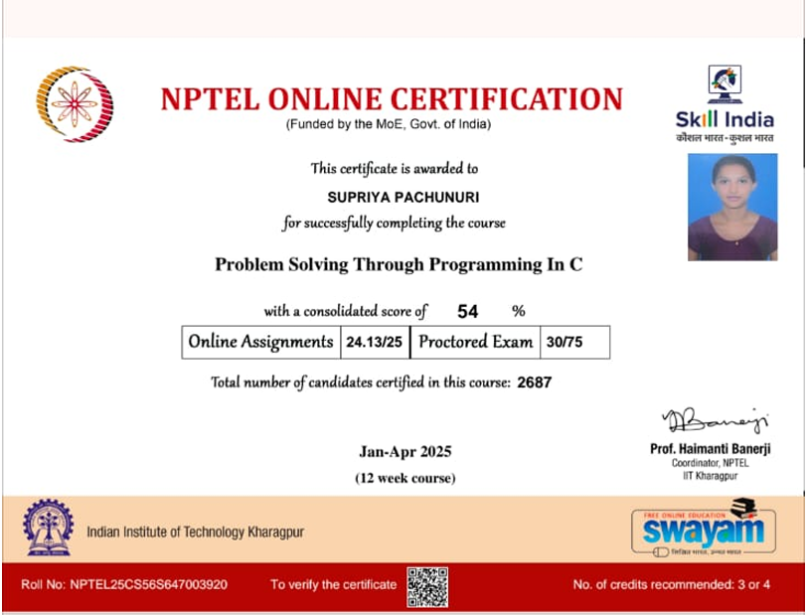
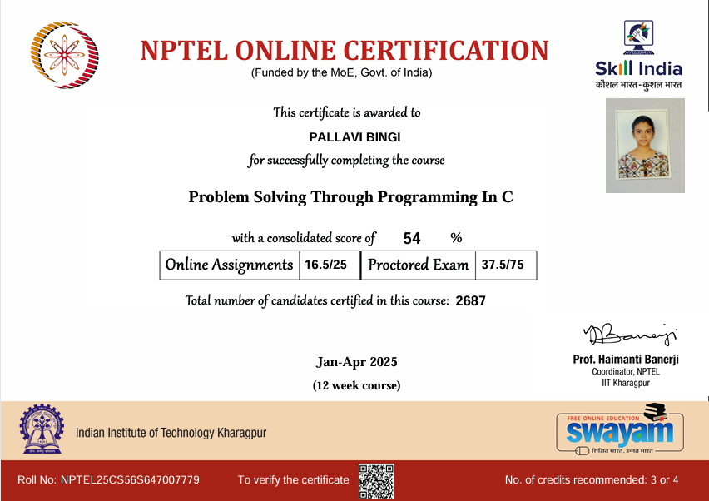

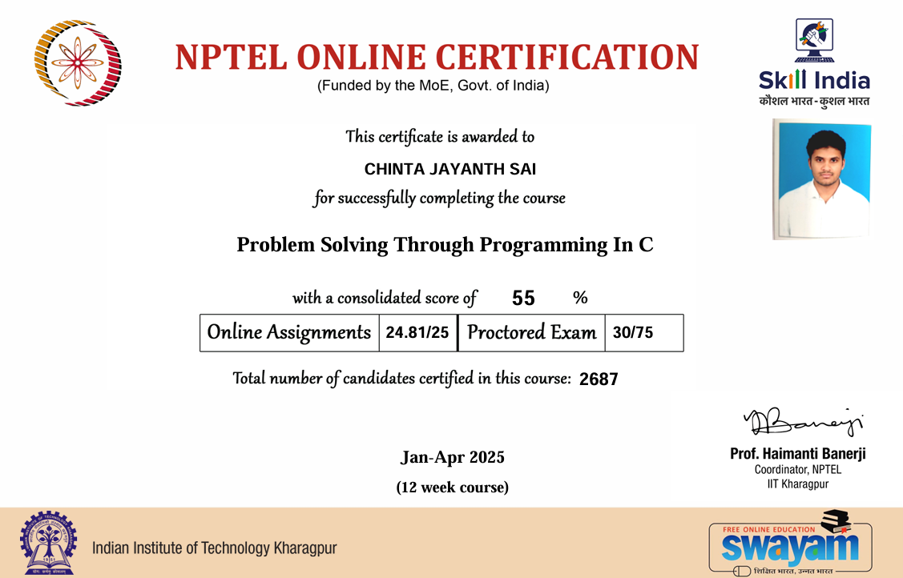
Department of Information Technology
Academic Year 2024-25
Problem solving through programming in C” Exam done in year 2024-Jan-April
S.NO | ROLL NO | NAME | SUBJECT NAME | PERCENTAGE
1. | 22AG1A1208 | B.Sunitha | Problem Solving through programming in C | 58%
2. | 22AG1A1249 | Uha Aravind Sai | Problem Solving through programming in C | 51%
3. | 22AG1A1262 | V.SriNithya | Problem Solving through programming in C | 60%
4. | 22AG1A1202 | Dharani Priya Reddy | Problem Solving through programming in C | 55%
5 | 23AG1A1230 | C. Hima bindhu | Problem Solving through programming in C | 64%
6 | 23AG1A1251 | P. Sri harshini | Problem Solving through programming in C | 56%
7 | 23AG1A1222 | D. Rakshith | Problem Solving through programming in C | 72%
8 | 23AG1A1235 | K. Maniraj | Problem Solving through programming in C | 55%
9 | 23AG1A1252 | P. Suchith | Problem Solving through programming in C | 61%
10 | 21AG1A1203 | A.Anish | Introduction to Internet of Things | 68%
11 | 23AG1A1209 | B. Raajitha | The Joy of Computing using Python | 58%
12 | 23AG1A1216 | D. Sravanthi | The Joy of Computing using Python | 77%
13 | 23AG1A1224 | G. Deekshitha | The Joy of Computing using Python | 62%
14 | 23AG1A1230 | CH. Hima Bindhu | The Joy of Computing using Python | 76%
15 | 23AG1A1232 | K. Bhavani | The Joy of Computing using Python | 55%
16 | 23AG1A1251 | P. Sri Hrahsini | The Joy of Computing using Python | 72%
17 | 23AG1A1220 | Dinesk Kunta | Programming in Java | 71%
18 | 23AG1A1224 | Deekshitha Gaini | Programming in Java | 60%
19 | 23AG1A1230 | Hima Bindhu .CH | Programming in Java | 65%
20 | 23AG1A1250 | P.Sushmika | Programming in Java | 63%
21 | 23AG1A1252 | Suchith Puppala | Programming in Java | 84%
22 | 23AG1A1253 | Ravva Baby | Programming in Java | 65%
23 | 23AG1A1241 | M. Navya Sri | The Joy of Computing using Python | 55%
24 | 23AG1A1246 | P. Rithika | The Joy of Computing using Python | 75%
25 | 23AG1A1261 | V. Sanjana Reddy | The Joy of Computing using Python | 64%
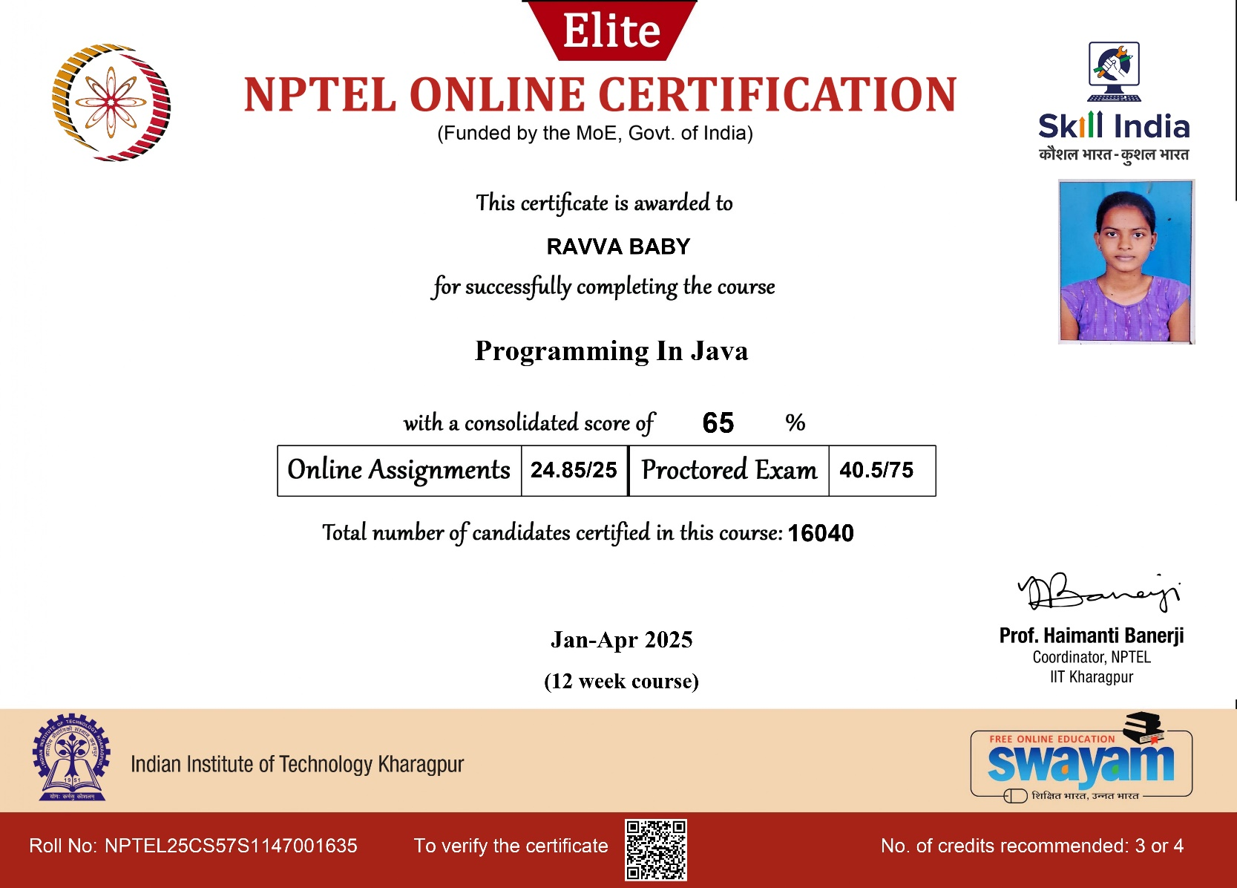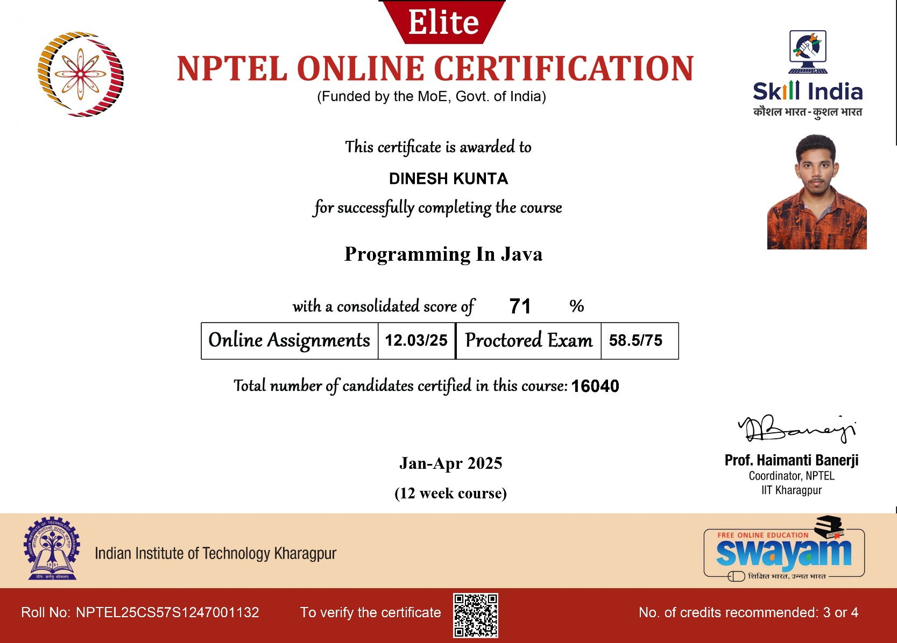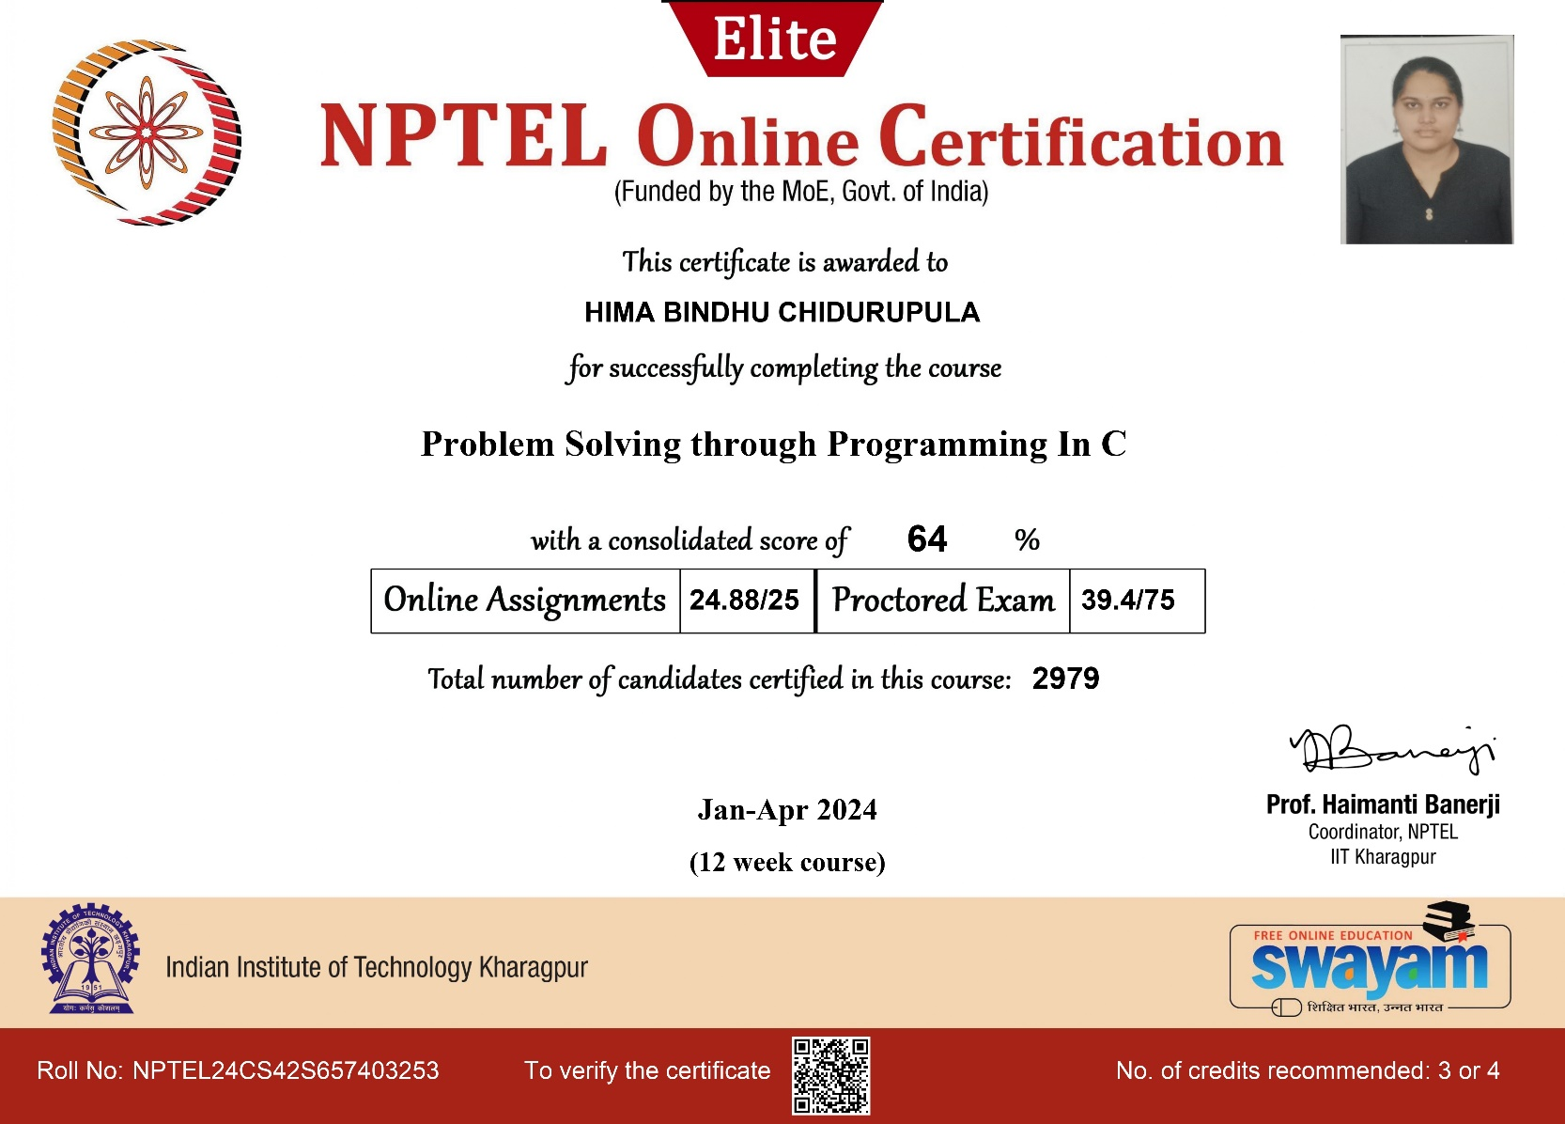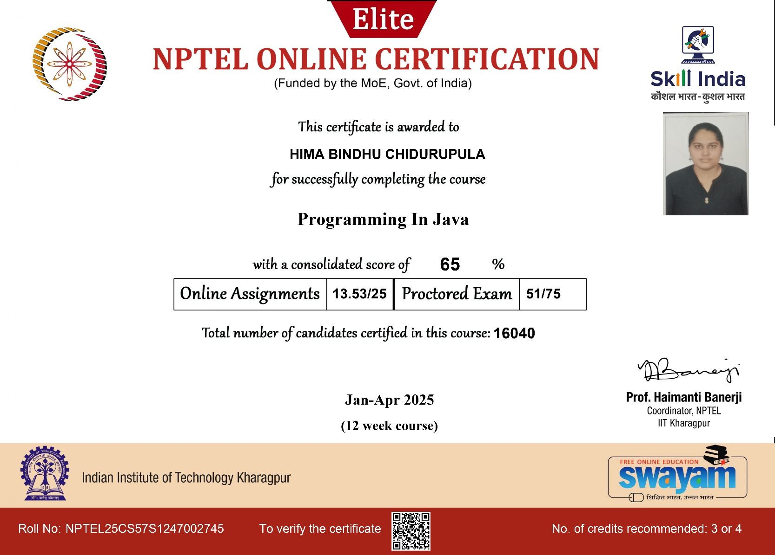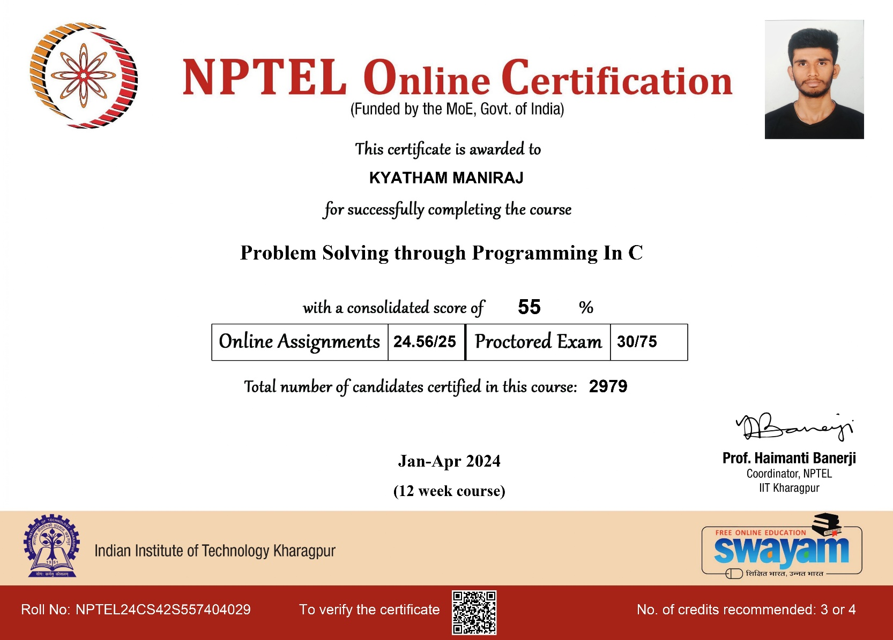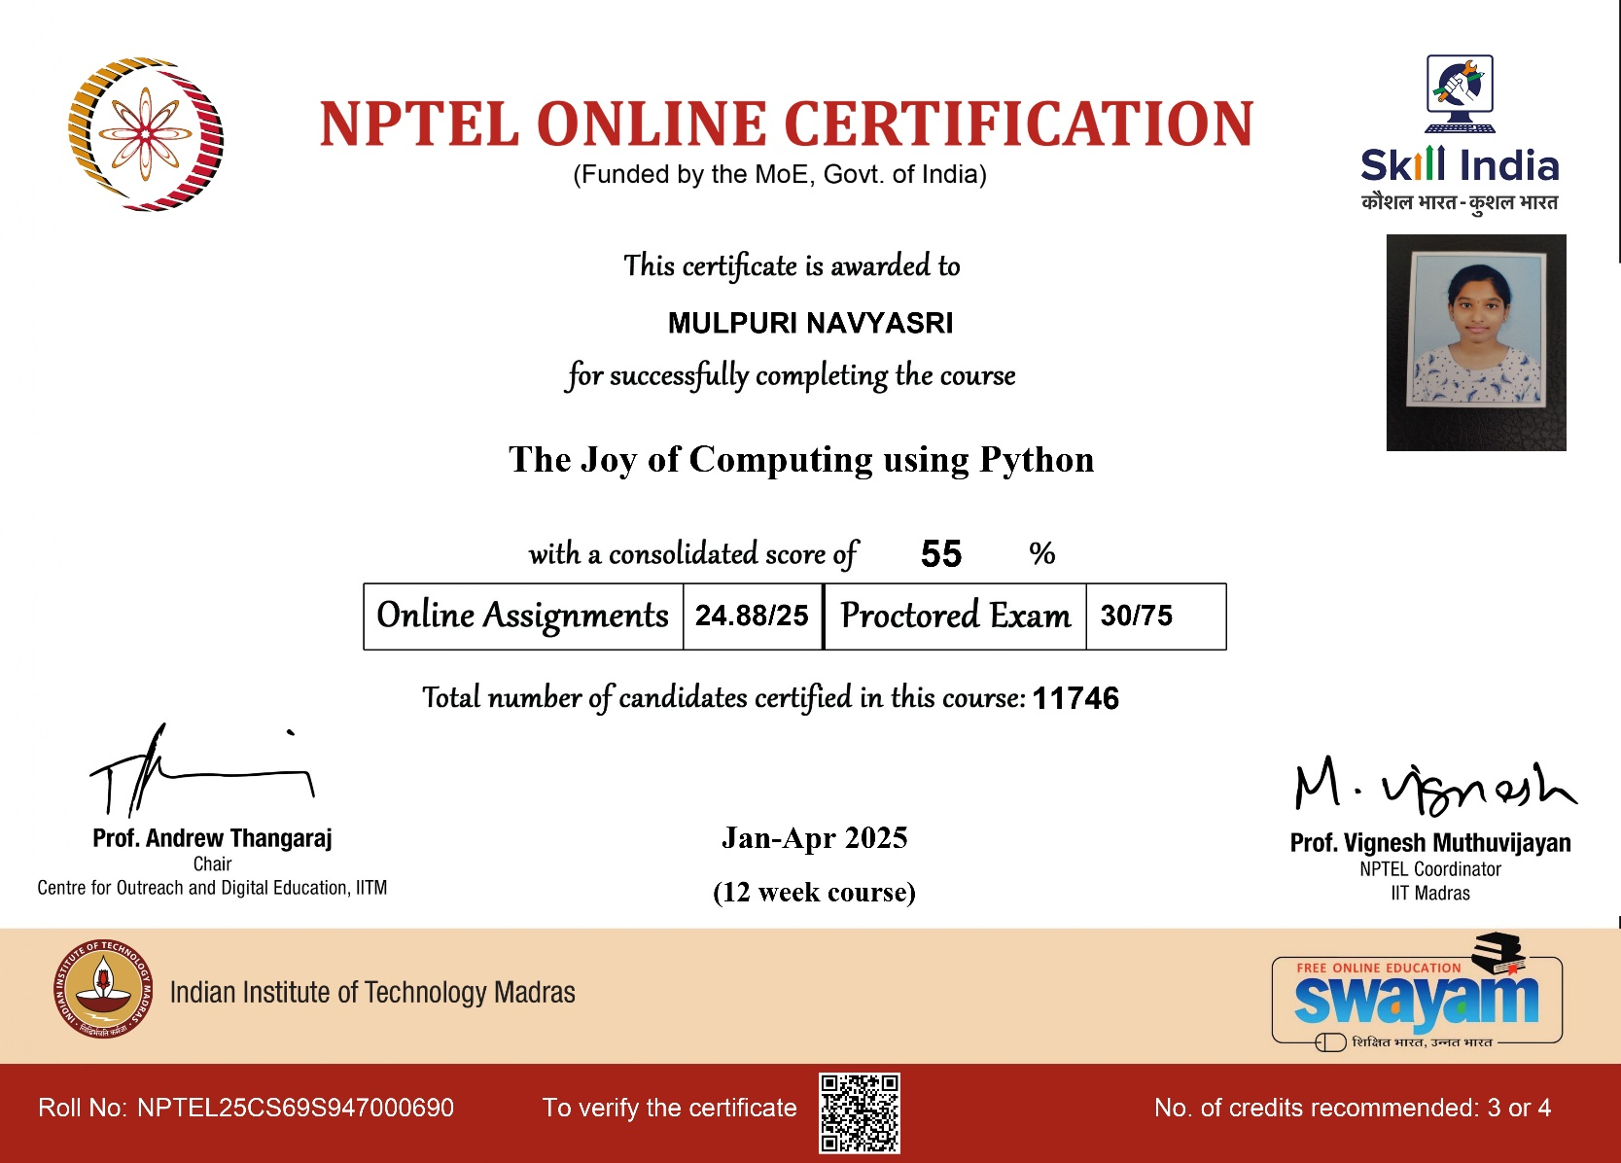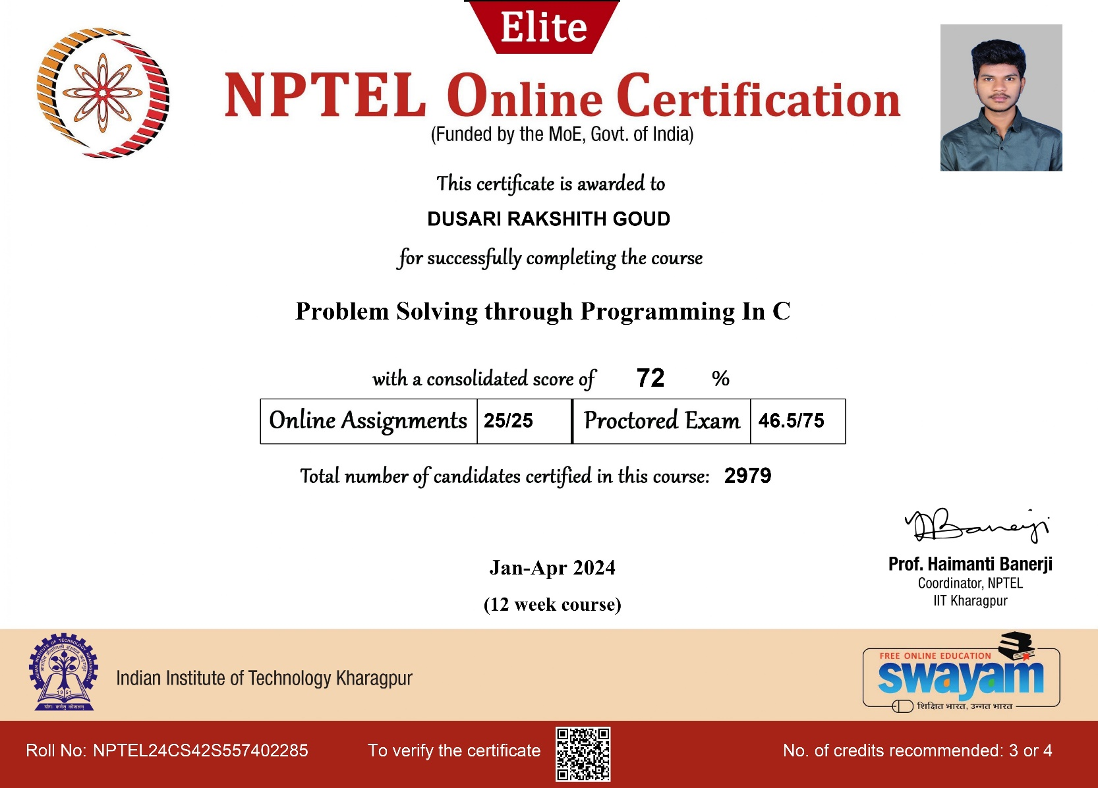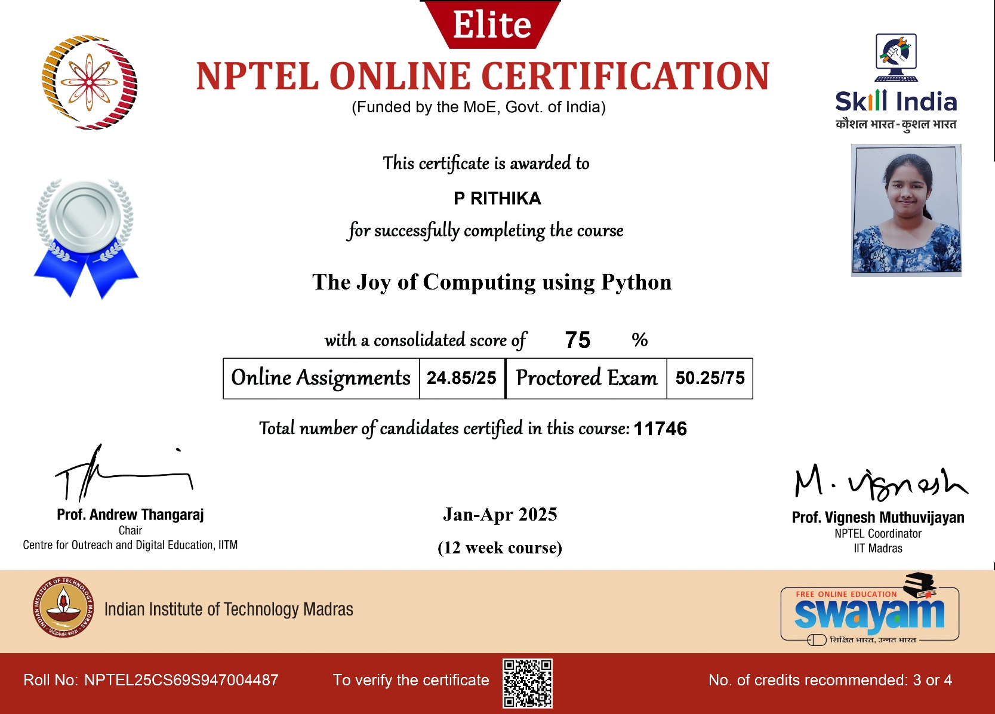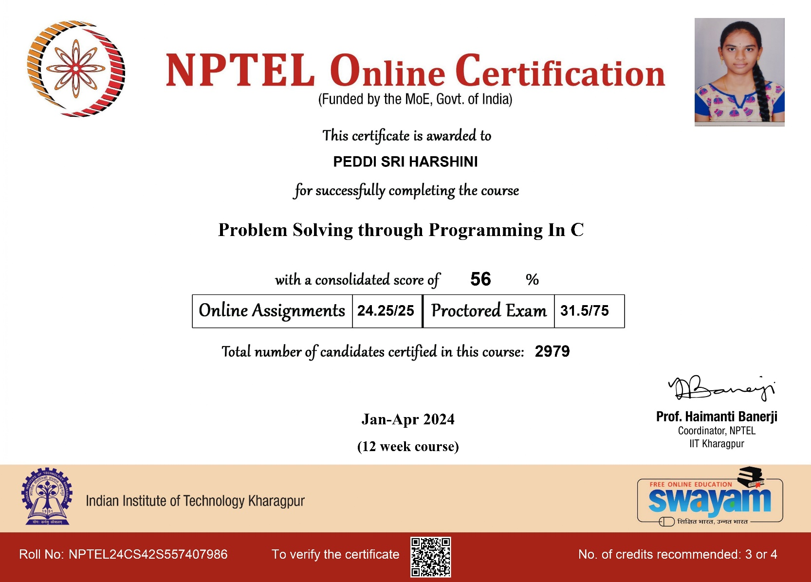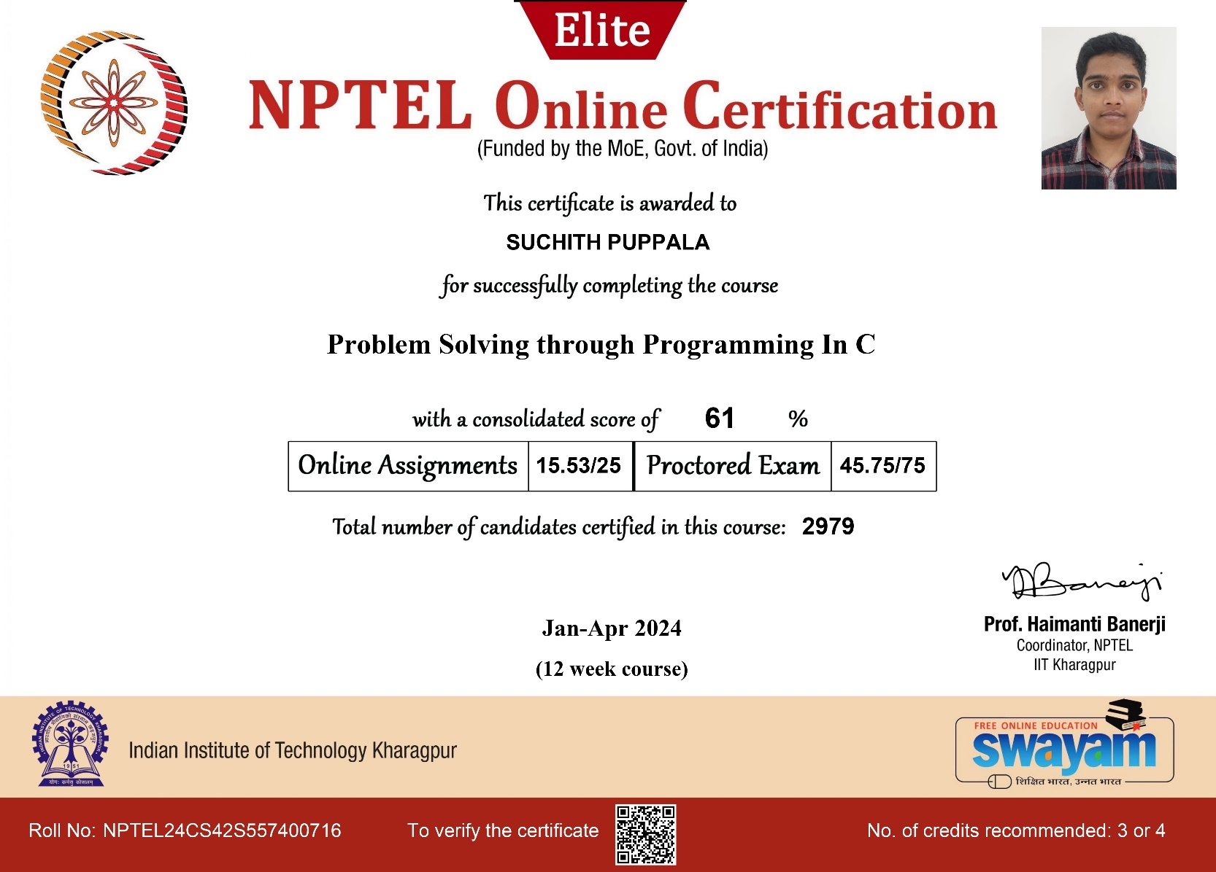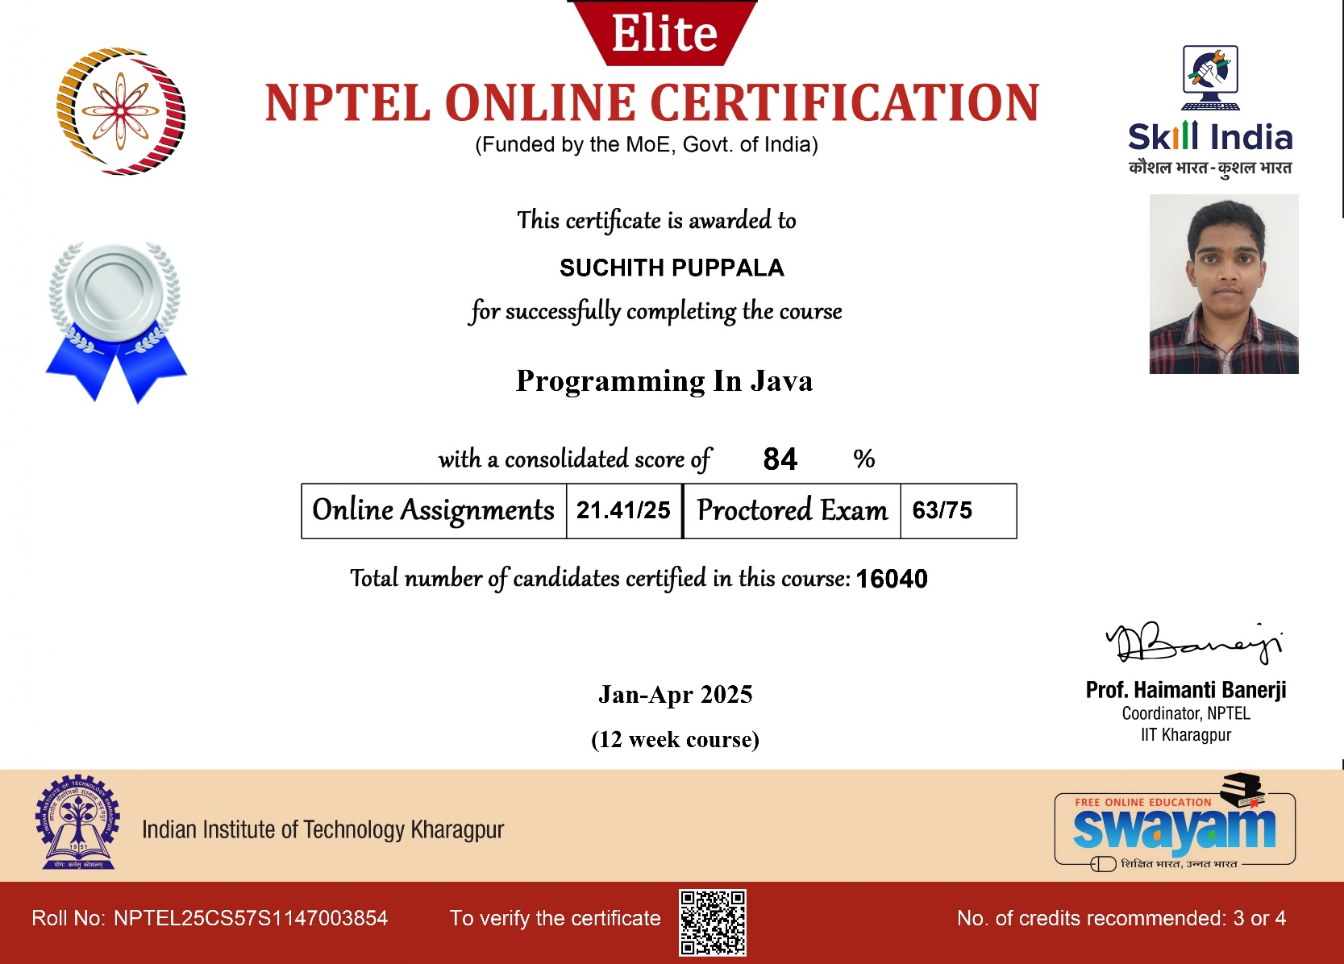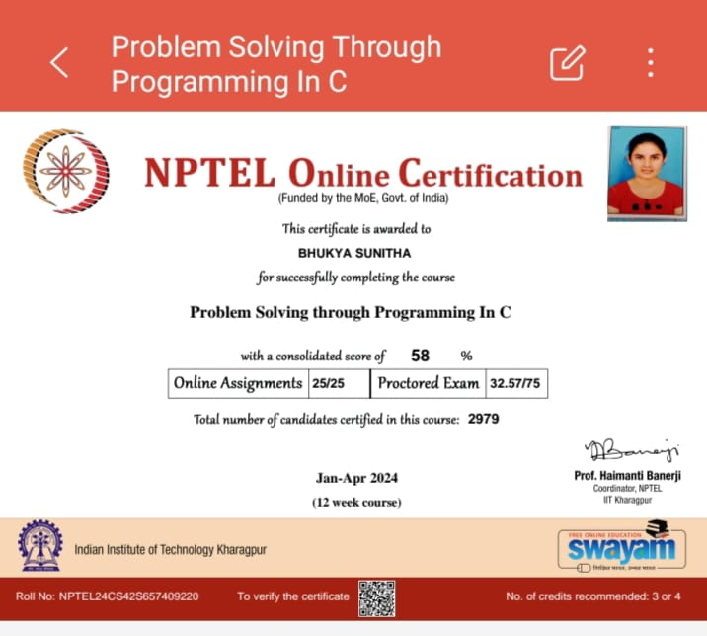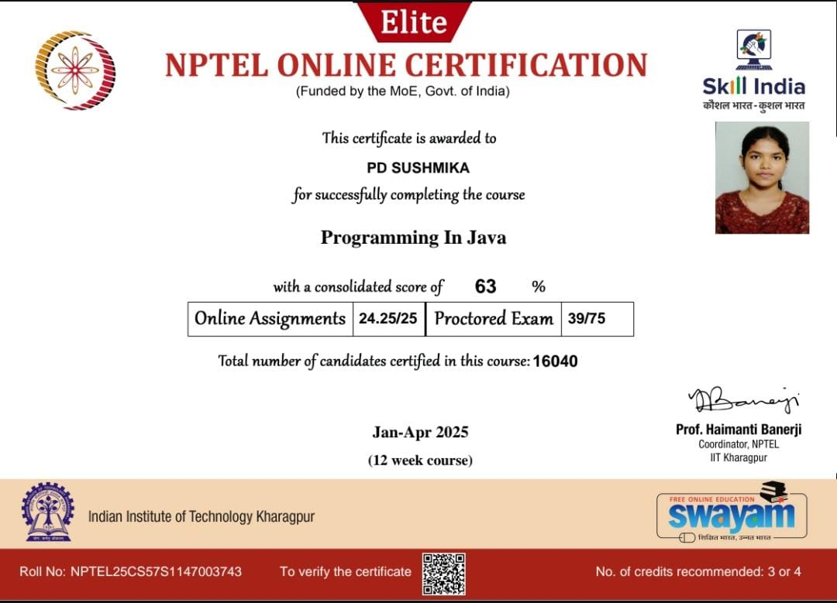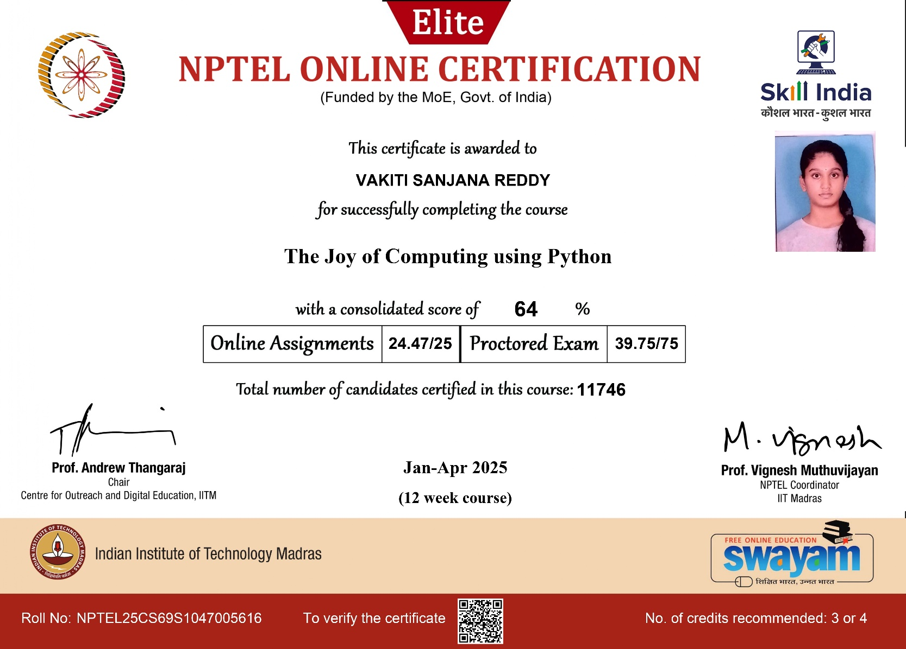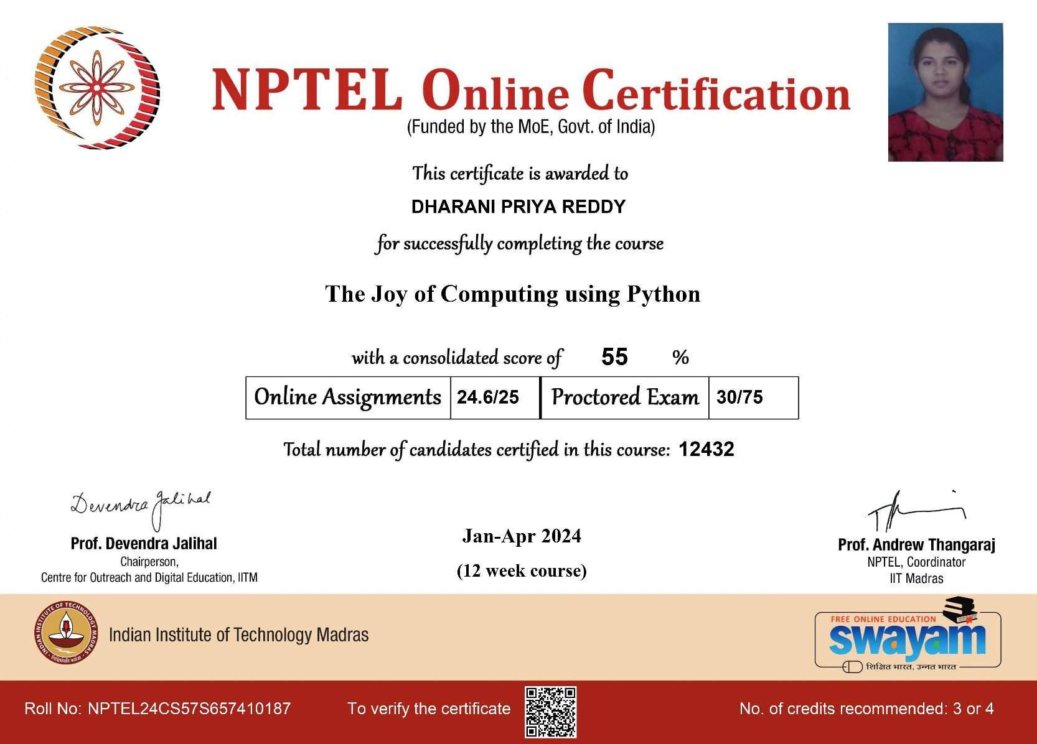
DEPARTMENT OF CSE (DATA SCIENCE)
Student NPTEL Certifications (A.Y 2024-2025)
S.no | Name of the Course | Roll No | Year & Section | Name of the Student | Timeline | Duration
1. | Programming in Java | 22AG1A6706 | III – A | BHEEMA SRI VAISHNAVI | Jul-Oct 2024 | 12 weeks
2. | Introduction to Algorithms and Analysis | 22AG1A6709 | III – A | SAI VINAY BOLLOJU | Jul-Oct 2024 | 12 weeks
3. | Data Analytics with Python | 22AG1A6709 | III – A | SAI VINAY BOLLOJU | Jan-Apr 2025 | 12 weeks
4. | Programming in Java | 22AG1A6709 | III - B | BOLLOJU SAI VINAY | Jan-Apr 2024 | 12 weeks

DEPARTMENT OF ARTIFICIAL INTELLIGENCE AND MACHINE LEARNING
Student NPTEL Certifications (A.Y 2024-2025)
S.no | Name of the Course | Roll No | Year & Section | Name of the Student | Timeline | Duration
1. | Problem Solving through Programming in C | 23AG1A7335 | II | Nakka Ram Uttang Naidu | July-Oct 2024 | 12 weeks
2. | Programming in Java | 23AG1A7342 | II | Pasumarthy Seetha Rama Krishna Sharma | Jan- Apr 2025 | 12 weeks
3. | Programming in Java | 23AG1A7335 | II | Nakka Ram Uttang Naidu | Jan-Apr 2025 | 12 weeks
4. | The Joy of Computing Using Python | 23AG1A7329 | II | Manthena SriHarshitha | 23AG1A7335 | 12 weeks
5. | Machine Learning for Engineering and Science applications | 23AG1A7329 | II | Manthena SriHarshitha | Jan-Apr 2025 | 12 weeks
6. | Recommender Systems | 23AG1A7329 | II | Manthena SriHarshitha | Feb-Apr 2024 | 8 weeks

